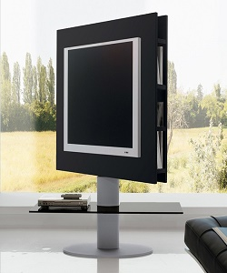

Unique TV stand

$22.87

Availability: In stock

### Description

Revolving TV-stand metal structure, aluminum finished; tempered glass shelf. This adjustable wooden TV stand characterized by a panel equipped with side shelves particularly useful to store CD, DVD, or small objects. Panel available in matt lacquer or wood veneer for a warmer and more textured look. The panel is also available in other several finishes.